**Aston Villa F.C. (AVL)**

Pre-Match Tactical Analysis

**Expected Line-up:**

Manager: **Unai Emery**

Formation**: 4-2-3-1**

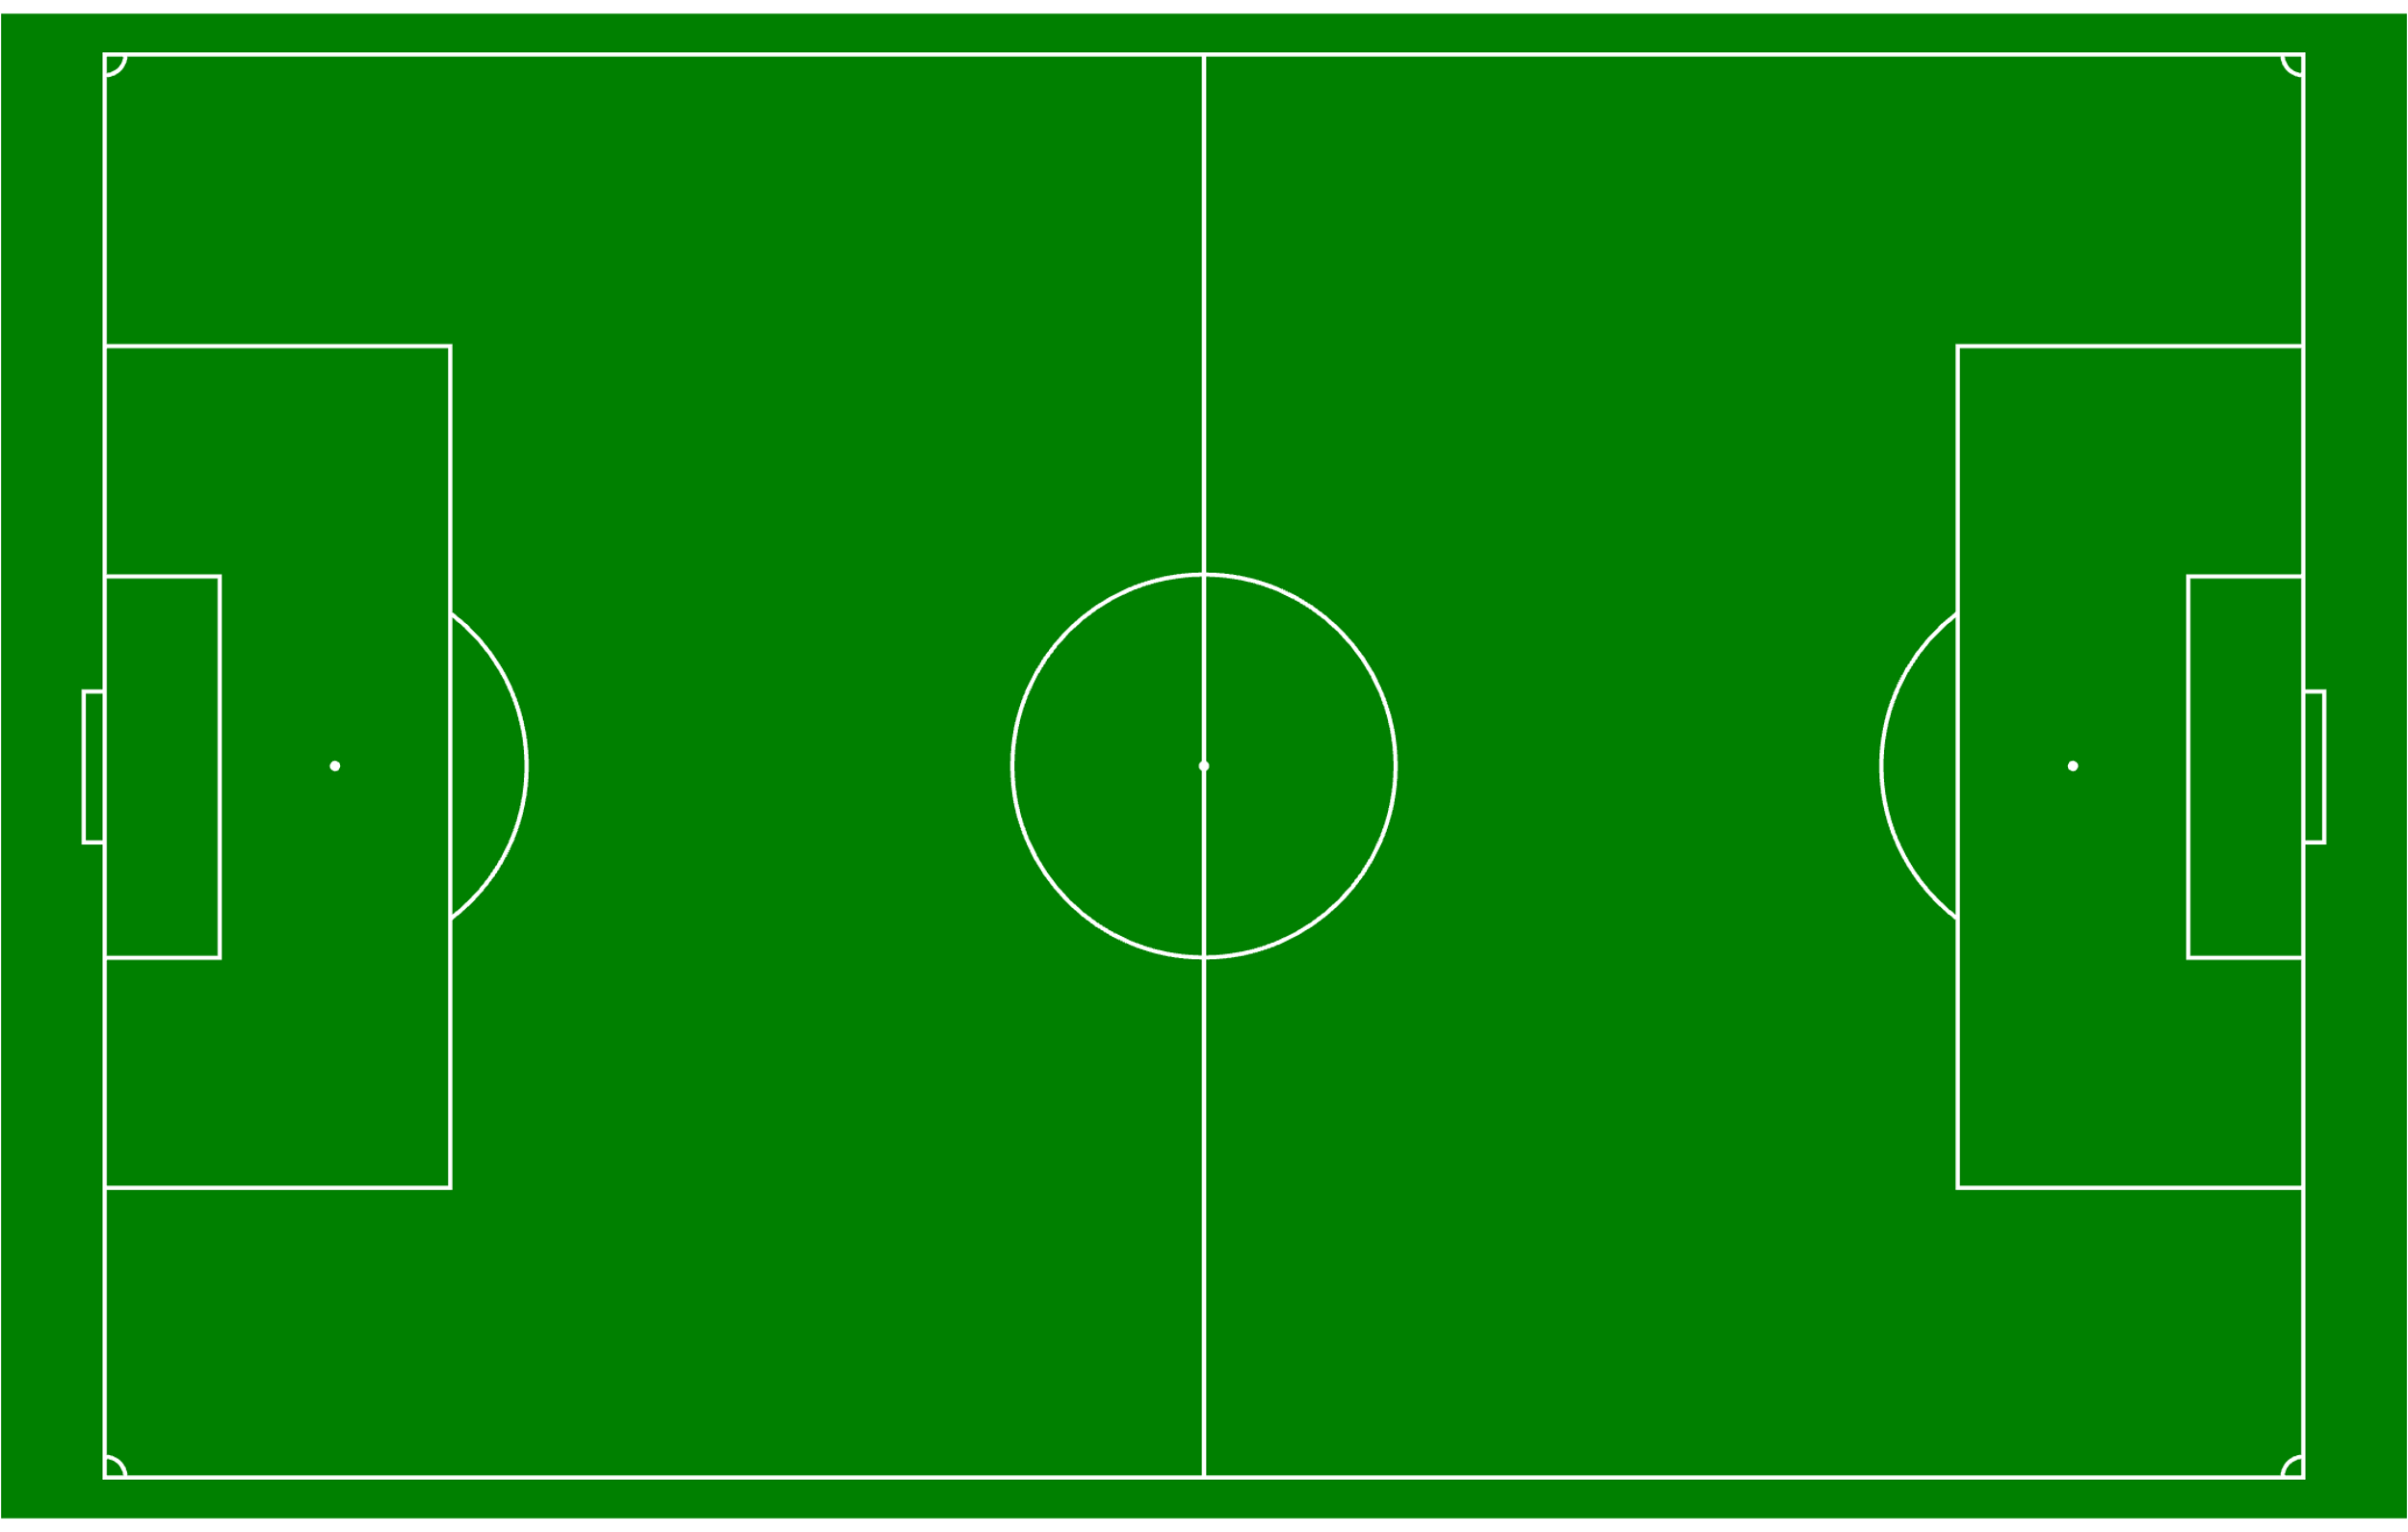

16

21

8

9

7

11

27

O. Watkins

M. Rashford

M. Asensio

Y. Tielemans

J. McGinn

A. Garcia

L. Digne

T. Mings

E. Konsa

D. Martinez

M. Rogers

12

5

4

23

**Injuries and Suspensions list*[1]***

***Injured Players***

#14 Pau Torres (Ankle)

#44 Boubacar Kamara (Thigh)

#24 Amadou Onana (Thigh)

#31 Leon Bailey (Other)

***Possible Returns from Injury***

#04 Ezri Konsa

#06 Ross Barkley

***Suspended Players***

#03 Axel Disasi (parent club)

***In-Possession Tactics***

*All charts and tables in the following section are created using data obtained from* [*FBRef via Opta*](https://fbref.com/en/comps/9/Premier-League-Stats)*.*

**Phase 1: Build-up**

* AVL have adjusted their build-up tactics based on the intensity of the opposition press over the season (*see figure 4*).
  + Spikes of increased launch rates against teams that press high such as Arsenal, Newcastle, and Brentford indicate their change in build-up tactics based on the opponent.
* However, **they generally prefer to play short and build from deep**, a tactic they have not deterred from in the past three games regardless of how the opposition is pressing (*see* *table 1*).
* However, Aston Villa are also prone to making a lot of errors at the back, having made 29 errors that have directly led to an shot against. Only Chelsea and Southampton have made more errors.

*Table 1:*

Goalkeeper Passing Metrics

|  |  |  |  |
| --- | --- | --- | --- |
| **Metric** | **EPL** **Ranking**  (high 🡪 low) | **Value** **per90** | **Value per90 (last 3 games)** |
| Launch Rate | 15th | 27.40% | 13.61% ↓ |
| Goalkicks: Average Length | 14th | 29.4 yards | 20.4 yards↓ |
| GK Open-Play Passes: Average Length | 14th | 30.9 yards | 23.8 yards↓ |

AVL’s low ranking in the above metrics, as well as their recently decreased average values in these metrics show their preference to play short passes when their goalkeeper is in possession, a clear indication of building from deep.

**What player(s) are frequently involved in this phase?**

* When in possession, they aim to build through the central areas, often using the **holding midfielders** to progress the ball forward.
* Y. Tielemans (#8) plays a vital role during the build-up phase for Aston Villa. He averages the **highest number of touches in the midfield third** (39.92 per90) and makes the **most progressive passes** (6.88 per90) for the club per game (*see figures 5 and 6*).

***Note:*** *Liverpool man-marked* ***Y. Tielemans (#8)*** *during AVL’s build-up phase, forcing them to build through the other holding midfielder, J. McGinn (#7). This led to multiple possession over-turns and 2 errors in AVL’s defensive third that directly led to a shot on goal.*

**Phase 2: Progression to Final Third**

* Continuing from their build-up phase, AVL aim to move the ball through the middle of the pitch, using the technical ability of their attacking midfielders to **dribble through the opposition midfield and carry the ball into the final third** (*see figure 1)*.

*Figure 1:*

Take-Ons Attempted vs Take-Ons Success Rate

*Table 2:*

Aston Villa: Midfield Progression Metrics

|  |  |  |
| --- | --- | --- |
| **Metric** | **Value** **per90** | **EPL** **Ranking**  (high 🡪 low) |
| Take-Ons: Successful | 8.84 | 5th |
| Take-Ons: Unsuccessful % | 41.3% | 15th |
| Fouls Drawn | 13.2 | 1st |

The chart and statistics above show that Aston Villa players take-on defenders more often than other teams, and that their players are more successful than average too.

**What player(s) are frequently involved in this phase?**

* Aston Villa’s three regular starting attacking midfielders – J. Ramsey (#41), M. Rogers (#27), L. Bailey (#31) – play very important roles in progressing the ball through the midfield thirds (*see figures 7 and 8*).
  + All three of them rank at the top among Aston Villa Players in terms of the amount of **Take-ons Attempted**, and **Carries into the Final Third**.
  + In fact, M. Rogers (#27) ranks 15th highest among all players (over 600 minutes) in the Premier League this season in terms of number of successful take-ons. His ranking shoots up to 2nd when you compare his statistics to just Premier League midfielders.

**Phase 3: Final Third**

* Aston Villa players are constantly looking to **find players making runs-in-behind the opposition defensive line** (*see figure 2*).

*Figure 2:*

Passes: Through Balls vs Offsides

Aston Villa have recorded the joint-highest number of through balls in the Premier League this season (2.52 per90). The chart above also indicates that their players are timing their runs better than average – getting caught offside just 1.36 times per90, the 4th lowest value in the league this season.

* Another important aspect of AVL’s tactics in the final third comes from an **attacking full-back putting crosses into the box** (*see table 3*).
  + Usually, the wide left midfielder – J. Ramsey (#41) – is positioned more centrally, occupying the half-space between the opposition full-back and centre-back.
  + This opens up space on the left wing for the left back L. Digne (#12), who takes up more attacking positions on the left wing.

*Table 3:*

Lucas Digne: Attacking Statistics (min. 630 minutes)

|  |  |  |
| --- | --- | --- |
| **Metric** | **Value** **per90** | **Player** **Ranking**  (high 🡪 low) |
| Attacking Third Touches (Defenders Only) | 22.67 | 6th |
| Crosses into the Penalty Box (All Players) | 0.74 | 9th |

Lucas Digne (#12) is the 6th most attacking full-back in the Premier League this season in terms of average number of touches in the attacking third (for players who have played at least 630 minutes). He also plays the 9th most crosses into the penalty box compared to any other player in the league this season.

**What player(s) are frequently involved in this phase?**

*Players involved in Creating Chances*

While L. Digne fulfils his role as an attacking full-back, Y. Tielemans, along with the three attacking midfielders – J. Ramsey, M. Rogers, L. Bailey – are primarily involved in the creation of chances for Aston Villa.

* These four players rank the highest in the club in several final third creation metrics such as **Through Balls**, **Key Passes**, **Passes into the Penalty Area**, and **Shot Creating Actions** (*see figures 9-12*).

*Players on the Receiving End of Created Chances*

O. Watkins is usually on the receiving end of these created chance, recording the **highest number of touches in the attacking box and shots among Aston Villa players** this season (*see figures 13 and 14*).

**How have Aston Villa changed their tactical approach in the Final Third post the January transfer window?**

The arrival of new right-back A. Garcia (#16) has **seen a shift in the player who plays as an attacking full-back** (*see table 4*).

* The two wide midfielders have also seemingly swapped roles, with the arrival of M. Rashford (#9) who now stays close to the touchline on the left wing, while M. Asensio (#21) and M. Rogers (#27) play more in the central and/or half-spaces on the right wing.
* This has opened up space for the right-back to take up a more attacking role, something that was observed in their recent game against Liverpool as well (*see figure 3*).

*Table 4:*

Change in L. Digne’s attacking role since the arrival of A. Garcia

|  |  |  |  |
| --- | --- | --- | --- |
| **Metric** | **L. Digne**  (Season Average) | **L. Digne**  (Average last 3 games) | **A. Garcia**  (Average last 3 games) |
| Touches: Attacking Third | 22.67 | 25.87 ↑ | 33.13 ↑ |
| Crosses | 6.24 | 5.93 ↓ | 6.71 ↑ |
| Progressive Passes Received | 5.89 | 5.39 ↓ | 7.16 ↑ |

The chart above shows that A. Garcia has been putting up higher numbers than L. Digne since his arrival at the club, indicating a possible change in preference for Unai Emery’s attacking full-back.

Figure 3:

Aston Villa: Attack Zones

vs Liverpool 24/25 season Average

*Source: WhoScored.com*

***Out-of-Possession Tactics***

*All charts and tables in the following section are created using data obtained from* [*FBRef via Opta*](https://fbref.com/en/comps/9/Premier-League-Stats)*.*

**Defensive Tactic**: Mid-Block

**Defensive Shape**: 4-4-2



16

21

8

9

7

11

27

O. Watkins

M. Rashford

M. Asensio

Y. Tielemans

J. McGinn

A. Garcia

L. Digne

T. Mings

E. Konsa

D. Martinez

M. Rogers

12

5

4

23

**Pressing Approach:** Medium Pressing Intensity

* Aston Villa often settle into their mid-block shape when defending, without pressing high up the pitch against teams (*see table 5*).
* However, loose touches and loose passes are often used as a trigger to press by AVL.

*Table 5:*

Metrics that indicate Aston Villa’s pressing approach

|  |  |  |
| --- | --- | --- |
| **Metric** | **Value per90** | **EPL Ranking**  (high 🡪 low) |
| Short Passes: Completion Rate (against AVL) | 91.8% | 1st |
| Medium Passes: Completion Rate (against AVL) | 88.2% | 5th |
| % of Tackles in Attacking Third | 13.26% | 14th |
| PPDA[2] | 12.34 | 14th |

The metrics above can be used to explain AVL’s pressing approach:

* Teams playing against AVL record some of the **highest short and medium length pass completion rates** compared to when they play other clubs on average, indicating that Aston Villa are happy to let other teams play short passes without asserting any pressure on their players.
* AVL also record a PPDA of 12.34 while making only 13.26% of their tackles in the attacking third, another indication of their Medium Pressing intensity.

***Defensive Line Height***: Low

* AVL’s mid-block tactic **restricts space vertically** against opponents by keeping the defensive, midfield, and attacking units close to each other.
* 4-4-2 shape allows them to cover wide areas while covering passing lanes through the middle.

*Player Movement*:

* The two Attackers put slight pressure on opposition central defenders, but don’t press very high – reducing space for the opposition midfielders
* Holding Midfielders play an important role in tracking opposition midfielders.
  + They are often responsible for tracking ‘deep-dropping’ midfielders during the opposition build-up phase.
* Wide midfielders settle into midfield 4, tracking opposition full-backs and helping out their defensive unit. They apply pressure to full-backs following a loose touch or pass.
* Once settled into their mid-block shape, AVL focus on covering passing lanes to midfielders and attackers.

**Goalkeeper Behaviour**

* Since their defensive line height is low, goalkeeper **E. Martinez (#23) is not asked to make sweeping actions**, averaging 0.96 sweeper keeper actions per90, ranking 15th in the league.
* However, **E. Martinez is strong in coming off his line**, especially to collect and/or punch out crosses into the box (*see table 6)*.

*Table 6:*

AVL Goalkeeper: Crosses Stopped Ranking

|  |  |  |
| --- | --- | --- |
| **Metric** | **Value per90** | **EPL Ranking**  (high 🡪 low) |
| GK: Crosses Stopped | 1.56 | 2nd |
| GK: Crosses Stopped % | 11.6% | 3rd |

***Transition Tactics***

**Defence to Attack Transition**: Fast Break

* AVL look to attack quickly upon winning the ball back, often moving through the middle.
* Their aim is to move the ball into the final third before allowing the opposition defensive shape to settle.

**Attack to Defence Transition**: Retreat into Mid-Block

* AVL look to settle into their mid-block defensive shape upon losing possession.
* However, they do sometimes counter-press through their holding midfielders especially when the loss of possession occurs in the middle of the pitch.

***Additional Relevant Metrics***

**Frequent Shots from Set-Pieces**

|  |  |  |  |
| --- | --- | --- | --- |
| **Metric** | **Value per90** | **EPL Average** | **EPL Ranking**  (high 🡪 low) |
| Shots: Set-Pieces | 4.4 | 3.51 | 1st |
| Shots: Set Pieces % | 32.03% | 26.91% | 3rd |

**Inaccurate Shooting**

|  |  |  |  |
| --- | --- | --- | --- |
| **Metric** | **Value** | **EPL Average** | **EPL Ranking**  (high 🡪 low) |
| Shots on Target % | 30.4% | 34.1% | 19th |
| Goals – xG | -2.6 | +0.16 | 14th |

**Poor Goalkeeper Performance**

|  |  |  |  |
| --- | --- | --- | --- |
| **Metric** | **Value** | **EPL Average** | **EPL Ranking**  (high 🡪 low) |
| Save % | 63.70% | 69.19% | 18th |
| Post-Shot xG – Goals Against | -2.7 | +0.36 | 18th |

**Poor in Aerial Duels**

|  |  |  |  |
| --- | --- | --- | --- |
| **Metric** | **Value** | **EPL Average** | **EPL Ranking**  (high 🡪 low) |
| Aerial Duels Win Rate | 48.3% | 50.12% | 18th |

***APPENDICES***

*Figure 4:*

*Figure 5:*

Aston Villa Players – Touches in the Midfield Third (min. 630 minutes)

*Figure 6:*

Aston Villa Players – Progressive Passes (min. 630 minutes)

*Figure 7:*

Aston Villa Players – Take-Ons Attempted (min. 630 minutes)

*Figure 8:*

Aston Villa Players – Carries into Final Third (min.

*Figure 9:*

Aston Villa Players –Through Balls (min. 630 minutes)

*Figure 10:*

Aston Villa Players –Key Passes (min. 630 minutes)

*Figure 11:*

Aston Villa Players –Shot Creating Actions (min. 630 minutes)

*Figure 12:*

Aston Villa Players – Passes into the Penalty Area(min. 630 minutes)

*Figure 13:*

Aston Villa Players – Shots (min. 630 minutes)

*Figure 14:*

Aston Villa Players – Touches: Attacking Box (min. 630 minutes)

1. Source: https://www.premierinjuries.com/injury-table.php
2. https://understat.com/league/EPL